Long Term Player Development (LTPD) - Camogie

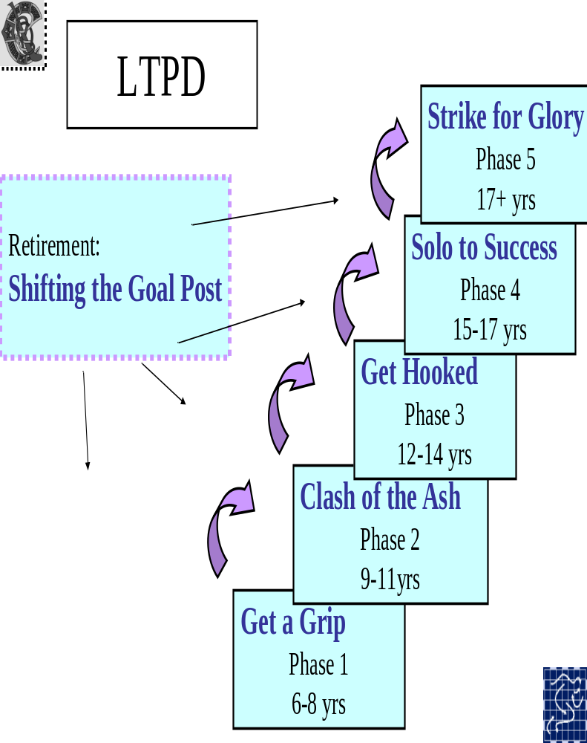

Long Term Player Development (LTPD)

Model for Camogie
The Technical Advisory Group (TAG) of the National Coaching and Training Centre (NCTC) has developed a draft model for Long-Term Player/Athlete Development. The main phases of the model are explained below. Please note that not all players will smoothly assimilate to all phases in a perfect manner. Many will develop different capacities at different rates. These phases have been adapted to Camogie for the development of a Camogie Player Pathway.

Phase 1 – Get a Grip

(6-8 yrs approx)
The main objective of this phase is to learn all the fundamental movement skills of Camogie such as correct running, jumping and throwing techniques
These movement skills should be taught in a positive manner using an organised and fun approach. Speed, power, strength and endurance are also developed in this phase in accordance with the level and ability of the physical development of the Camogie player. It is important that the Camogie player participates in as many sports as possible during this phase to further develop the fundamental movement skills.

Phase 2 – Clash of the Ash
(9-11yrs approx)
The Camogie player is learning how to play and practice the fundamental skills of the game of Camogie during this phase. Continued development of the Fundamental movement skills from the ‘Get a Grip Phase’ should be encouraged. This is important because the ability of a Camogie Player to reach her full potential will be compromised if fundamental movement skill training is not developed between the ages of eight to eleven.

Phase 3 – Get Hooked
(12-14 yrs approx)
During this phase the Camogie player is learning how to train practice and play the game effectively. Accuracy of Camogie skill is being further developed. This phase addresses critical periods for strength and aerobic development. Both strength and aerobic trainability is dependent on maturation levels, not chronological age. In this phase players are also introduced into the competitive aspects of the game as part of a full team.

Phase 4 – Solo to Success

(15-17 yrs approx)
During this phase the Camogie player is training to compete. Optimising fitness preparation and performance is therefore necessary during this phase. To achieve this, high intensity individual- and match-specific training is provided to the players. Sport specific skills are performed under a variety of competitive conditions during training. Players will train to play in club / school practice matches as well as more competitive league/championship games.

Phase 5 – Strike for Glory
(17+ yrs approx)
All of the Camogie player’s capacities are now fully established and players are training to peak for major matches/ competitions. The aim is to maximise fitness preparation, individual and Camogie specific skills as well as performance. Training is high intensity and relatively high volume with appropriate rest and recovery breaks.

Retirement -Shifting the Goalposts
This phase refers to the activities performed after a Camogie player has retired from Camogie training and competitions permanently. Retirement can occur at any age. The aim of this phase is to retain Camogie players for coaching, sport administration, officiating or any other Camogie-related career
Get a Grip – 6-8 yrs approx

Technical Capacities

Get a Grip Phase
During this phase, the player will…….
Develop fundamental movement skills – run, jump, throw, catch, strike and kick appropriate to levels of development
Develop passing technique appropriate to level of development
Identify dominant hand
Identify Lock Grip/position
Identify Ready Grip/position
Identify Lift Grip/position
Swing on dominant side using correct technique
Strike on the ground on dominant side
Block on the ground
Tackle on the ground
Clash on ground
Dribble ball along ground
Use correct equipment appropriate to age and level
Use appropriate clothing and footwear
Know the correct body position when executing a skill
Hook a player who is striking ball on ground

Tactical Capacities

Get a Grip
During this phase, the player will……….
Adhere to basic rules and ethics
Play Go-Games to learn basic attack and defence skills

Physical Capacities

Get a Grip
During this phase, the player will……….
Develop endurance through fun activities (e.g.) Bib tag
Develop wrist strength through fun activities (e.g.) squeeze ball
Display agility through fun games/activities
(e.g) bull dog
Develop balance through fun games
(e.g.) Zig zag relay
Develop hand/eye co-ordination through fun games (e.g.) skittles, piggy in the middle
Develop arm/leg co-ordination through fun games (e.g.) ball to cone
Develop linear, lateral and multi-directional speed through fun games (e.g.) Here there and everywhere
Develop arm strength through fun activities (e.g.) bunny jumps, tug of war
Develop movement skills in limited space through fun games

Mental Capacities

Get a Grip
During this phase, the player will……….
Experience enjoyment/ fun from Camogie
Show enthusiasm for Camogie as an activity
Develop confidence in executing basic skills
Exhibit a feeling of accomplishment when playing Camogie

Imagine themselves as their role model to improve skills

Lifestyle Capacities

Get a Grip
During this phase, the player will……….
Play a range of sports/activities
Learn safe use of equipment (e.g.) wearing of a helmet and shin guards
Learn safety in game/ training scenario (e.g.) when clashing/tackling
Play at home

Personal Capacities

Get a Grip
During this phase, the player will……….
Experience enjoyment/fun
Demonstrate fair play/respect
Demonstrate sportsmanship
Develop self-confidence
Develop social skills through interaction with others
Be part of a team atmosphere

Make friends through Camogie

Clash of the Ash – 9-11 yrs approx

Technical Capacities

Clash of the Ash Phase
During this phase, the player will……….
Develop basic skill of:
Strike ball on the ground
Demonstrate the skill of striking the ball on the ground in a fluid way
Develop basic skill of:
Strike ball on both left and right sides
Demonstrate the skill of striking the ball on both the left and right sides in a fluid way
Develop basic skill of:
Lifting sliotar while stationary
Demonstrate the skill of lifting the sliotar while stationary in a fluid way
Develop basic skill of:
Lifting sliotar while on the run
Develop basic skill of:
Striking sliotar in the air on dominant side
Demonstrate the skill of striking in the air on dominant side in a fluid way.
Develop basic skill of:
Catching sliotar at chest level
Demonstrate the skill of catching sliotar at chest level in a fluid way.
Develop basic skill of:
Handpassing sliotar from the hand.
Demonstrate the skill of handpassing sliotar from the hand in a fluid way.
Develop basic skill of:
hooking
Demonstrate the skill of hooking in a fluid way
Develop basic skill of blocking
Demonstrate the skill of blocking in a fluid way
Develop the skill of Clashing
Develop the skill of batting down a high ball
Develop 1st touch control of sliotar
Practice technical skills outside of controlled practice- repetitive learning

-Against a wall
Practice technical skills outside of controlled practice- repetitive learning
-With a friend (1)
Practice technical skills outside of controlled practice- repetitive learning
-With a group of friends
Practice technical skills outside of controlled practice- repetitive learning
-Everyday

Tactical Capacities

Clash of the Ash
During this phase, the player will……….
Line out in different positions on pitch
Name the different positions on pitch (e.g.) full back
Experience playing in different positions on pitch
Play modified games (e.g) ground hurling/ lift and strike
Play small-sided games (e.g.) Go Games
Use skills of striking, tackling, lifting in small sided games
Use skills of striking, tackling, lifting in small sided games with conditioned game rules
Identify and adhere to rules for frees
Identify and adhere to rules for sidelines
Identify and adhere to rules for wides
Identify and adhere to rules for starting a Game

Physical Capacities

Clash of the Ash
During this phase, the player will……….
Develop wrist and ankle stability
Progress development of agility, balance and co ordination (abc’s) to a level where movement is fluid.
Progress development of speed with control of body/hurley
Identify the benefits of basic warm-up-
Identify when to warm up
Follow instructions on how to warm up
Identify the benefits of basic cool-down-
Identify when to cool down
Follow instructions on how to cool down
Demonstrate repetitive specific actions to develop leg and arm strength (e.g.) soloing task
Perform basic mobility exercises (e.g.) side steps, skipping, zig zag
Move and control body in limited space

Develop power through fun games (e.g.) bunny jumps

Perform basic flexibility exercises

Mental Capacities

Clash of the Ash
During this phase, the player will……….
Develop confidence in using a variety of skills in a game situation
Continue to show enthusiasm for Camogie through participation and commitment
Develop concentration Skills (e.g.) keeping eye on the ball all of the time

Learn how to control anxiety

Develop decision making skills in small sided games (e.g.) when to pick up the ball or pull on the ground

Lifestyle Capacities

Clash of the Ash
During this phase, the player will……….
Continue to play multiple sports and activities
Incorporate regular Camogie training into everyday life
Develop good practice habits to develop independence
Develop commitment to regular training schedule

Apply safe practices

Play with peers at home

Personal Capacities

Clash of the Ash
During this phase, the player will……….
Experience enjoyment/fun
Develop social interaction with peers and mentors
Develop teamwork and interaction skills
Develop respect for officials and decisions
Be aware that effort and time spent playing the game will result in improved and consistent performance
Accept rules, regulations and structures

Get Hooked – 12-14 yrs approx

Technical Capacities

Get Hooked
During this phase, the player will……….
Perform technical skills well from both left and right sides
Demonstrate the skill of lifting sliotar on the run in a fluid way.
Execute skills at speed
Execute skills in pressure situations (e.g.) while being tackled for possession
Perform the following skill proficiently:
-Strike sliotar in the air
Perform the following skill proficiently:
-Strike sliotar from left and right sides
Perform the following skill proficiently:
-Strike ball on dominant side in the air while on the run
Perform the following skill proficiently:
-Handpass off the hurley
Perform the following skill proficiently:
- Hooking
Perform the following skill proficiently:
-Blocking
Perform the following skill proficiently:
-Clashing
Perform the following skill proficiently:
-Batting down high ball
Perform first touch control of sliotar in a fluid way
Perform the following skill :
-Catch sliotar overhead
Perform the following skill :
-Solo ball
Perform the following skill :
-Shoot accurately
Perform the following skill:
-Free taking
Perform the following skill:
-Side line cuts

Continue practising technical skills outside controlled practice session

Individualise skills training to address strengths and weaknesses

Engage in specific target practice

Tactical Capacities

Get Hooked
During this phase, the player will……….
Implement key game principles such as running off the ball

Use peripheral vision
Learn to create space
Support players on the ball

Use a game plan

Identify the number worn by the person that plays in a particular position on pitch

Identify and adhere to match rules
Develop decision making
-on skill selection
Develop decision making
-on positioning
Control and maintain possession of the ball under pressure
Identify the different positional skill requirements
Demonstrate different positional skills

Play practice matches developing positional skills

Play competitive games to apply positional skills

Begin self-analysis in training and competition

Physical Capacities

Get Hooked
During this phase, the player will……….
Develop aerobic and anaerobic endurance
Undertake flexibility training given the rapid growth of bones, tendons, ligaments and muscles
Continue to develop ankle, shoulder, elbow and wrist stability
Develop core and spine stability
Identify when to do dynamic stretching
Perform dynamic stretching
Identify when to do static stretching
Demonstrate static stretching exercises for different muscle groups of the body (e.g.) quadriceps, hamstrings
Continue to develop speed- linear, lateral and multi directional
Continue to develop leg and arm strength using own body resistance
Develop peripheral vision through small sided games and specific group activities (e.g) line soloing and passing

Mental Capacities

Get Hooked
During this phase, the player will……….
Keep positive and accept that self-worth is not linked to performance
Continue to develop confidence in using a variety of skills in a game situation
Continue to develop concentration Skills – in using self-talk, thought stopping
Further develop decision making skills in small sided games (e.g.) what type of pass to use.

Use structured goal-setting

Practise and understand the importance of breathing for controlling anxiety

Develop performance and pre-performance routines

Display a motivation to succeed

Learn to control emotions

Learn to cope with success and set backs

Develop the use of imagery particularly in the areas of set pieces.

Use imagery for practising and improving technique and tactics

Use imagery for general motivation and improving self-confidence

Lifestyle capacities

Get Hooked
During this phase, the player will……….

Apply correct nutrition before, during and after practice/match
Apply correct hydration before, during and after practice/match
Integrate the importance of rest and recovery in both practice and match sessions
Learn how to manage time (e.g.) balance Camogie and school life

Develop skills to deal with peer pressure

Participate in complementary sports

Identify the signs of fatigue

Follow planned and periodised training programmes

Begin to use self-monitoring e.g. Keep a diary of training

Personal Capacities

Get Hooked
During this phase, the player will……….
Develop and progress social interaction skills
Learn to work in a team environment
Develop positive communication skills
Display personal discipline
Display commitment to team ethos
Show dedication to both the team and the sport of Camogie
Begin to include the concept of deliberate practice into everyday play
Display personal responsibility in relation to personal organisation of (e.g.) playing gear and getting to matches
Display commitment to improve/achieve goals
Continue to display respect for officials and competitors in the game
Understand the changes that puberty will bring and its implications for training

Solo to Success – 15- 17years approx

Technical Capacities

Solo to Success
During this phase, the player will……….

Display confidence in performing Camogie skills including goal keeping skills
Display consistency in performing Camogie skills including goal keeping skills
Display control in performing Camogie skills
Practise skills under competitive conditions
Undertake an intensity of training relevant to competition and opposition.

Display individual style of play

Perform the following skill:
-Flick ball on ground

Perform the following skill:
-Flick ball in the air

Tactical Capacities

Solo to Success
During this phase, the player will……….
Undertake advanced team play when in possession
e.g use of long ball/diagonal ball

Take sidelines
Adopt a specific role within the team, when taking opposing teams’ strengths/weaknesses into account.

Adapt to opponents game plan
Read the game and move on and off the ball accordingly

Adapt game plan to climate wet/wind/heat

Continue self-analysis in training and competition

Apply decision making in relation to skill selection

Apply decision making in relation to positioning

Implement principles of attack and defence

Undertake competition simulation training

Practise position-specific tactical preparation

Adhere to competitive strategies

Physical Capacities

Solo to Success
During this phase, the player will……….
Undertake intense physical conditioning as part of a team

Undertake physical conditioning as an individual
Undertake physical conditioning appropriate to your field position
Emphasise individual preparation that addresses individual strengths and weaknesses
Maintain core strength/stability
Undertake Speed Agility and Quickness
Sessions (SAQ)
Prepare optimally taking into account the concept of
Tapering / peaking
Take appropriate rest and recovery breaks between training sessions and matches

Mental Capacities

Solo to Success
During this phase, the player will……….
Develop confidence through improved technique, tactical understanding and competitive performance
Use self talk/trigger words/ thought stopping to focus attention and deal with distractions
Develop personal responsibility – undertake independent mistake detection and correction

Develop decision making skills
Set goals for technical, tactical, physical, mental, lifestyle and personal areas

Use pre performance and performance routines constantly

Develop personal routines and refine

Adhere to team routines

Display patience
Use imagery for practising strategies and dealing with different situations/problems
Explore relaxation techniques (e.g) Deep breathing and incorporate into performance and pre performance preparation

Identify the importance of practising mental skills

Develop skills to cope with social pressures

Lifestyle Capacities

Solo to Success
During this phase, the player will……….
Engage in planning and perioidisation of training
Monitor the signs of fatigue and develop appropriate recovery strategies
Continue to develop time management skills
Develop a support network
Develop responsibility for personal preparation before training/games

Acquire increased knowledge on hydration/nutrition

Develop a deeper understanding of rest/recovery so to avoid burnout and prevent injuries.
Manage college/career/intercounty aspirations

Apply for GAA/Camogie bursaries

Monitor oneself using a training log/diary

Prepare for different environments e.g. heat/cold/rain

Apply injury prevention measures

Personal Capacities

Solo to Success
During this phase, the player will……….
Continue getting to know oneself, physically/socially/mentally/emotionally etc

Display a balanced lifestyle

Display personal responsibility and involvement in decision making

Learn to combine playing Camogie with family, school and life goals

Address economic and independence issues

Train and compete ethically and fairly

Strike For Glory – 17+ approx

Technical Capacities

Strike for Glory
During this phase, the player will……….
Refine all Camogie skills including goalkeeping skills

Ensure competition specific training skills are automatic

Improvise skills, if necessary
Undertake high quality technical training
Display control in performances
Display consistency in performances

Tactical Capacities

Strike for Glory
During this phase, the player will……….
Develop effective competition strategies

Identify team strengths

Identify opposition weaknesses

Adapt strategies to game situations

Practice tactics and strategies in training for matches

Identify importance of organisation in matches

Comply with the team organisation

Identify importance of communication in matches

Communicate effectively to team-mates

Communicate effectively to others, ie coach

Use Match analysis techniques

Continue to apply self-analysis in training and competition

Take Penalties

Physical Capacities

Strike for Glory
During this phase, the player will……….
Maximise physical fitness training to allow you to compete effectively for the complete duration of a Camogie match
Maintain core body strength

Continue to use stretching to prevent injury
Implement a personal flexibility programme
Undertake individual fitness programmes to address strengths and weaknesses
Apply appropriate recovery strategies to prevent injuries e.g. rest, ice, stretching.
Train to peak for major competitions.
Use Tapering/peaking for optimal performance
Engage in physical testing pre and post training programme to gage effectiveness (e.g.) flexibility testing, endurance testing

Mental Capacities

Strike for Glory
During this phase, the player will……….
Display independent decision making
Conform to team ethos

Use imagery incorporating tactics, problem-solving, pre-performance and performance routines

Take positive corrective advice from mentors

Possess well developed and refined mental skills

Display a will to win

Continue to set goals for all aspects training and performance

Individualise and refine relaxation techniques.

Use refocusing plans/coping strategies

Continue to undertake competition simulation training to practise mental capacities

Refine strategies to cope with pressure

Lifestyle Capacities

Strike for Glory
During this phase, the player will……….
Continue to integrate rest/relaxation into everyday training
Take frequent breaks between intensive training sessions

Refine self monitoring

Maximise an integrated support network/structure (e.g.) family/friends/team mates/coach

Continue to monitor the signs of fatigue and optimise recovery strategies

Continue career/sports planning

Balance work and sporting life

Critically assess performance

Personal Capacities

Strike for Glory
During this phase, the player will……….
Show ability to combine family life/Camogie/friends
college/career
Display discipline and personal responsibility
Compete ethically and fairly
Demonstrate Fair play and sportsmanship
Be a positive role model

Retirement from Play:
Shifting the Goal Post Phase

Coach

Option
Referee
Original
‘Goal post’
of Play

Administrator

Option
Option
Option
Option
Integration Officer

Club/School Liason Officer

Other Options

Children’s Officer
Sub Committee Member within Club (e.g.)
Finance or coaching and games committee

Manager

Shifting the Goalpost Phase – General Capacities
During this phase, the player will change from being a player and display the following capacities…….
Retain skills and can apply in recreational context

e.g puck around using hurling wall
Retain recreational involvement
Use knowledge of the game to enjoy it
Keep physically active (e.g.) aerobic training

Maintain flexibility
Use different relaxation methods

Undergo a smooth transition from player to non player

Adjust to non competitive environment
Pursue other interests (e.g.) night courses

Pursue personal and family life more strongly

Enjoy a healthy lifestyle

Reset goals

Engage in some club activities (e.g) administration/coaching

Develop other skills to apply to the game of Camogie

Maximise skills already attained and apply to Camogie

Shifting the Goalpost Phase – Option - Coach

Display dedication to the job and sport
Implement Knowledge and rules of the game
Apply Coaching qualification
Maintain physical Fitness

Demonstrate good organisational Skills

Demonstrate Planning skills

Display approachability
Apply analysis and observatory skills

Demonstrate good communication skills

Display efficiency

Demonstrate reliability

Demonstrate Trustworthiness

Display Fairness

Display enthusiasm for coaching

Develop players skills

Provide feedback to players

Provide fun and enjoyment for players

Improve Player Performance

Shifting the Goalpost Phase – Option - Administrator

Display dedication to the job and sport
Apply Knowledge of the game
Display Leadership and management skills
Display Integrity

Demonstrate good organisational Skills
Practice being computer literate

Demonstrate Planning skills

Apply vision in relation to the club
Display Knowledge of the rules

Demonstrate good communication skills

Display efficiency

Demonstrate reliability

Shifting the Goalpost Phase – Option - Referee

Display dedication to the job and sport
Implement Knowledge and rules of the game
Apply Referee qualification
Maintain physical Fitness

Demonstrate good organisational Skills

Demonstrate Planning skills

Apply Fairness during a game
Apply analysis and observatory skills

Demonstrate good communication skills

Display efficiency

Demonstrate reliability

Demonstrate Trustworthiness

Shifting the Goalpost Phase – Option - Manager

Display dedication to the job and sport
Demonstrate Knowledge and rules of the game
Display Leadership and management skills
Display firmness in running the team

Demonstrate good organisational Skills

Demonstrate Planning skills

Demonstrate good communication skills

Display efficiency

Demonstrate reliability

Demonstrate Trustworthiness

Exhibit Enthusiasm

Shifting the Goalpost Phase – Option – Integration Officer

Display dedication to Integration and sport

Exhibit Knowledge of the Integration Process
Demonstrate Knowledge of the not only Camogie but the other sports under the integration umbrella (e.g) Ladies Football, hurling
Display Leadership and management skills
Display firmness in portraying Camogie

Demonstrate good organisational Skills

Demonstrate Planning skills

Demonstrate excellent communication skills

Display efficiency

Demonstrate reliability

Demonstrate Trustworthiness

Demonstrate Co-operation in relation to integration

Exhibit Enthusiasm for the Integration process

Liase with others within own sport and other sports in relation to Integration progression

Promote the benefits of working together under the Integration Process

Shifting the Goalpost Phase – Option – Children’s Officer

Promote awareness of the Code of Ethics and Good Practice for young players within the club and particularly among the players and their parents/guardians and mentors
Demonstrate Knowledge of CCG Code of Ethics and Good Practice for Children in Sport
Ensure all mentors are aware of practices within the Code
Act as an advisory resource on best practice for all in club
Report regularly to Club executive Committee
Display dedication to the job of children’s Officer

Demonstrate good communication skills

Display efficiency

Demonstrate reliability

Demonstrate Trustworthiness

Shifting the Goalpost Phase – Option – Club/School Liaison Officer

Liase with Local School Principals

Promote increased participation

Display dedication to the job of Club/School Liaison Officer
Monitor development of club players at primary and secondary school levels
Introduce new students at schools level to the local Camogie club
Promote inclusiveness to all from the school into the club

Demonstrate good organisational Skills

Demonstrate Planning skills

Display approachability
Liase with coaches in the schools and the clubs in relation to player development

Demonstrate good communication skills

Display efficiency

Demonstrate reliability

Demonstrate Trustworthiness

Display Fairness

Display enthusiasm for the sport and increasing participation

Promote fun and enjoyment of the sport to the young players

Shifting the Goalpost Phase – Option – Sub Committee Member (e.g.) Finance or Coaching & Games committee

Display dedication to the committees work
Apply vision in relation to the club

Demonstrate good organisational Skills

Demonstrate Planning skills in relation to the aims of the sub committee

Display approachability

Demonstrate good communication skills

Display efficiency

Demonstrate reliability

Demonstrate Trustworthiness

Display enthusiasm for the work of the sub committee

Demonstrate excellent administrative skills

Report to the executive of the club on a regular basis

